1/ Download MySQL Installer via: https://dev.mysql.com/downloads/installer/

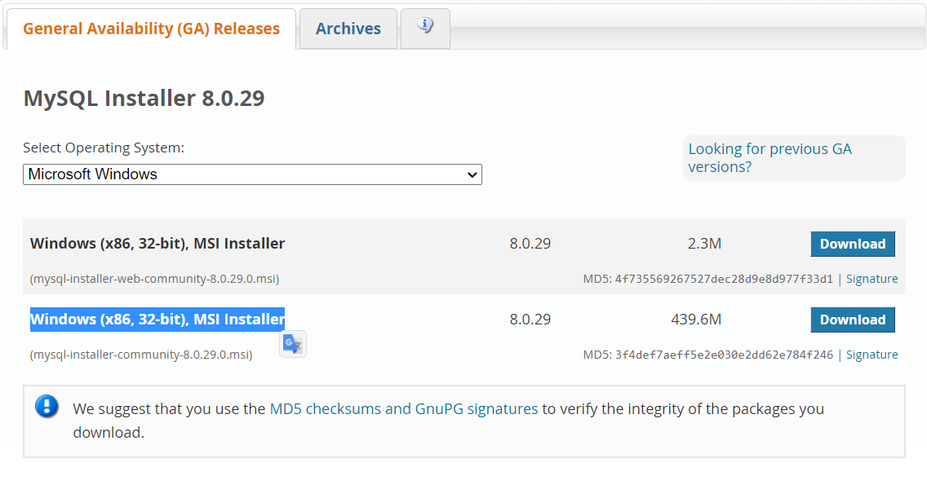

2/ Download MySQL workbench via: https://dev.mysql.com/downloads/workbench/

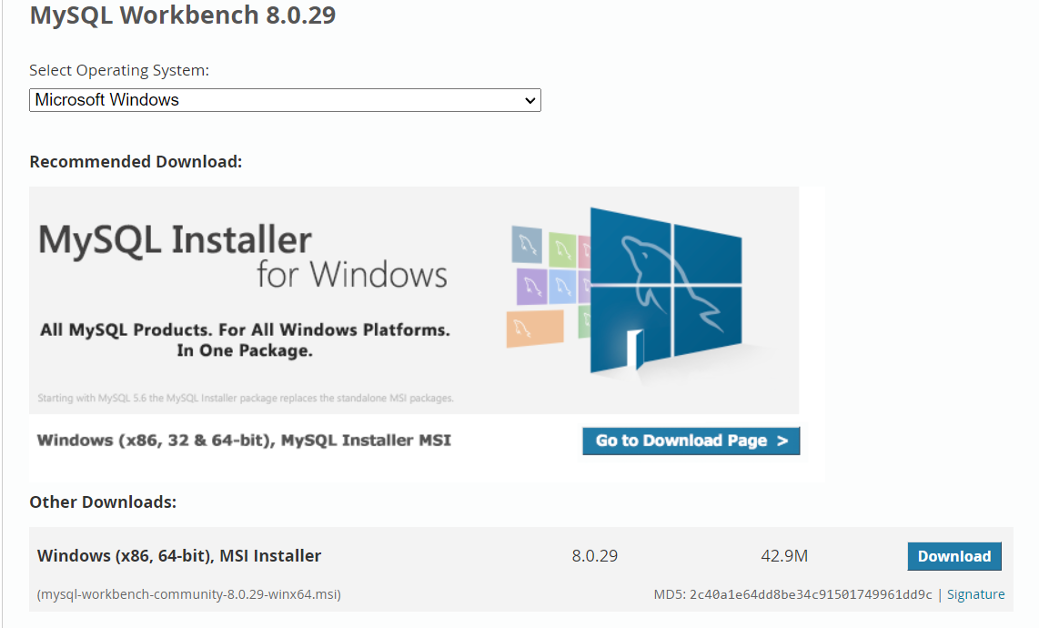

3/ Install MySQL installer and My SQL workbench

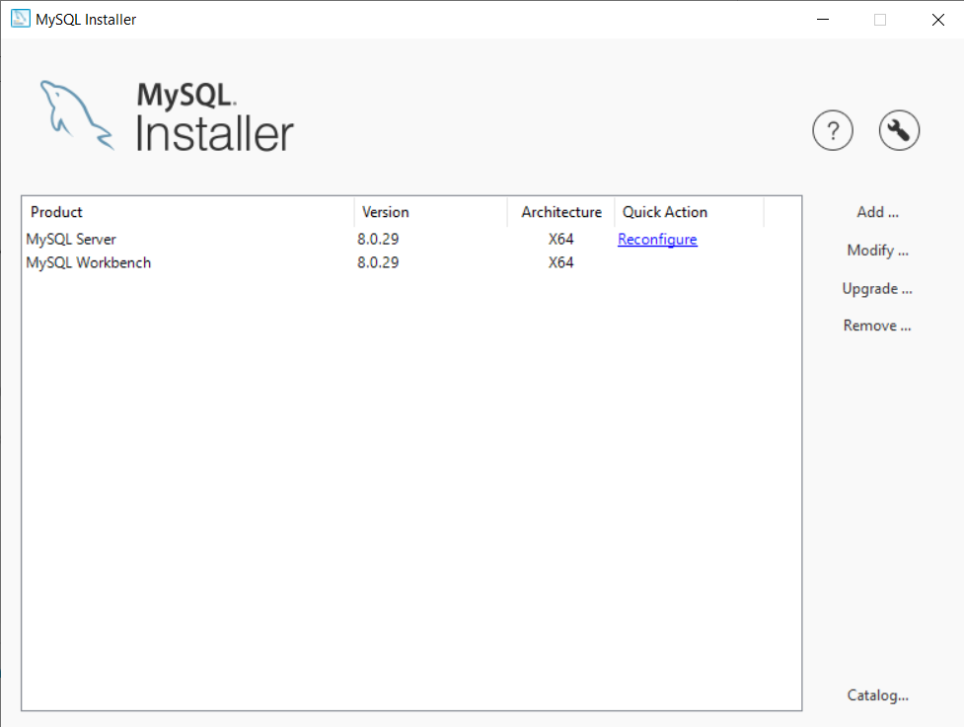

(Screenshot after open and install the installer)

3A/ Setup server through MySQL installer

Add

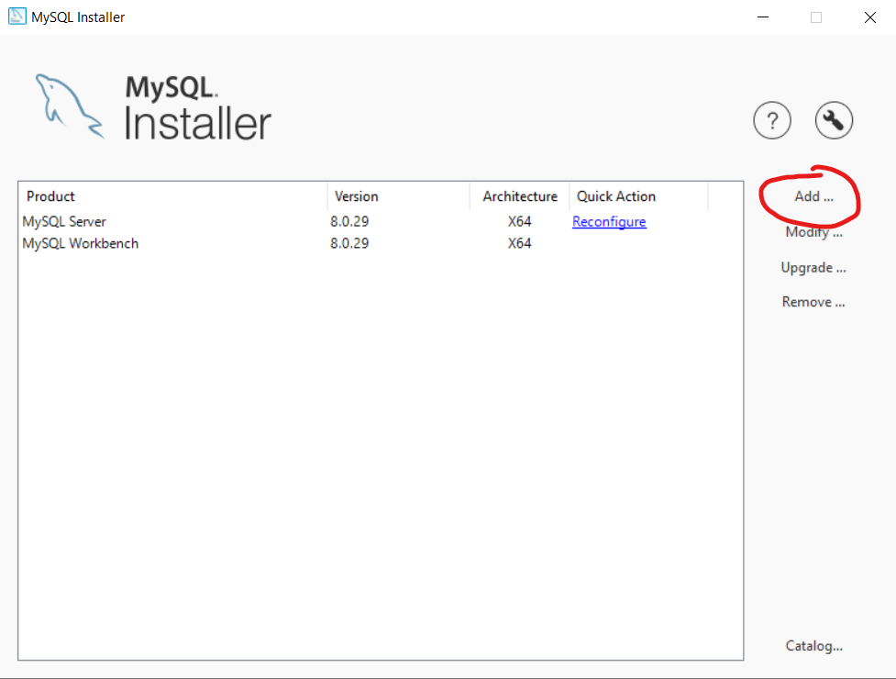

3B/ Choose the following

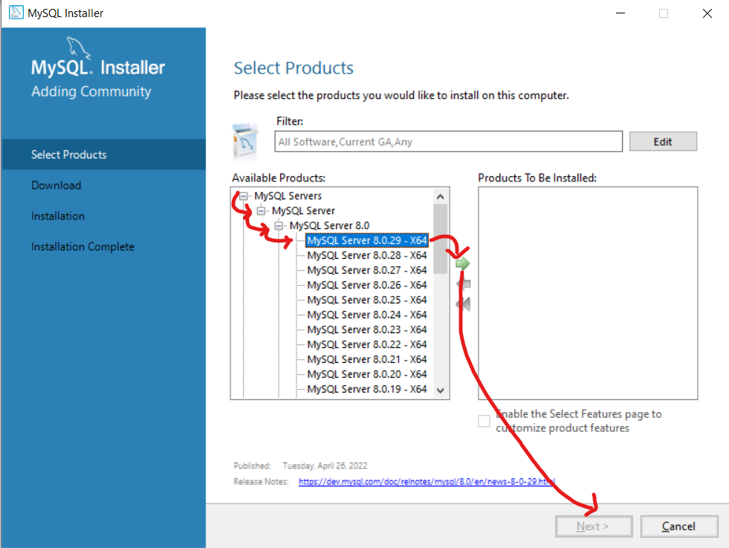

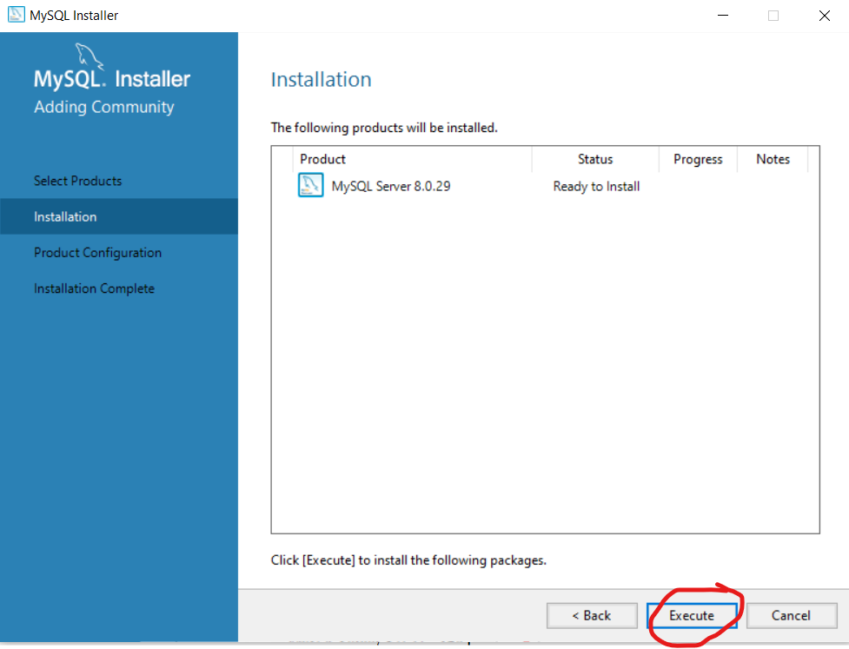

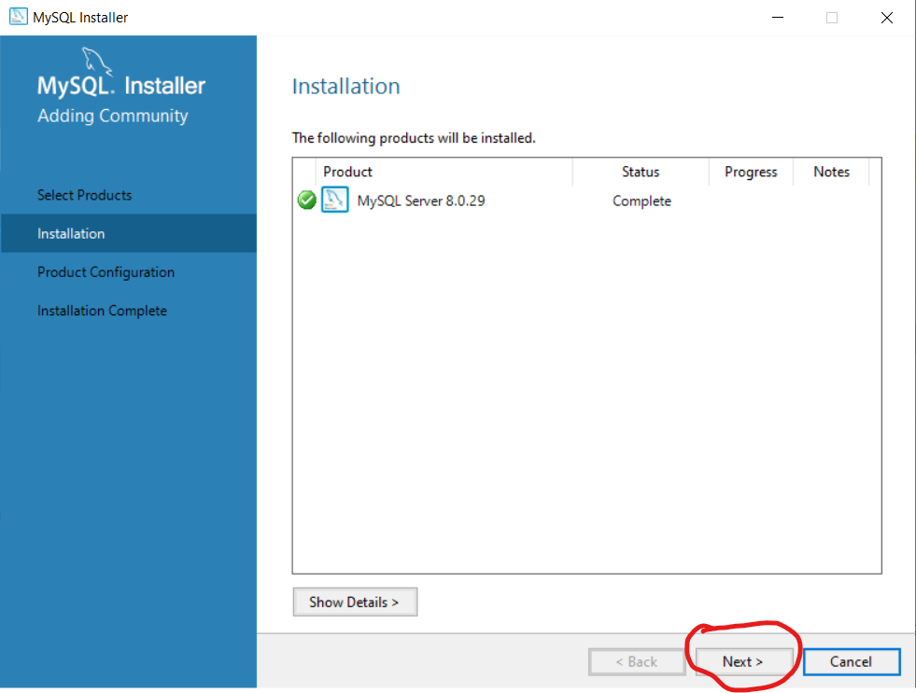

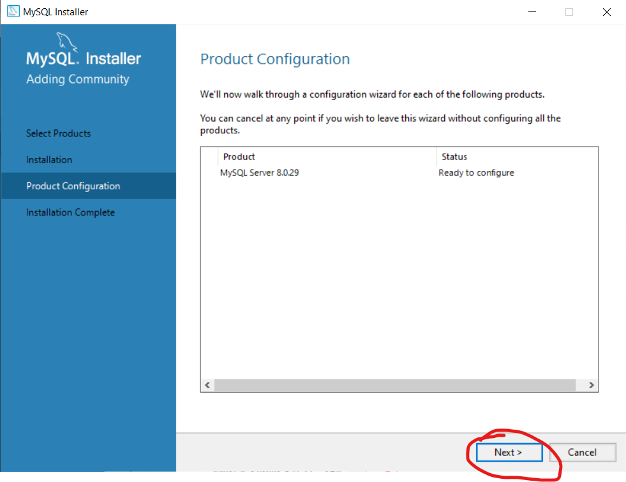

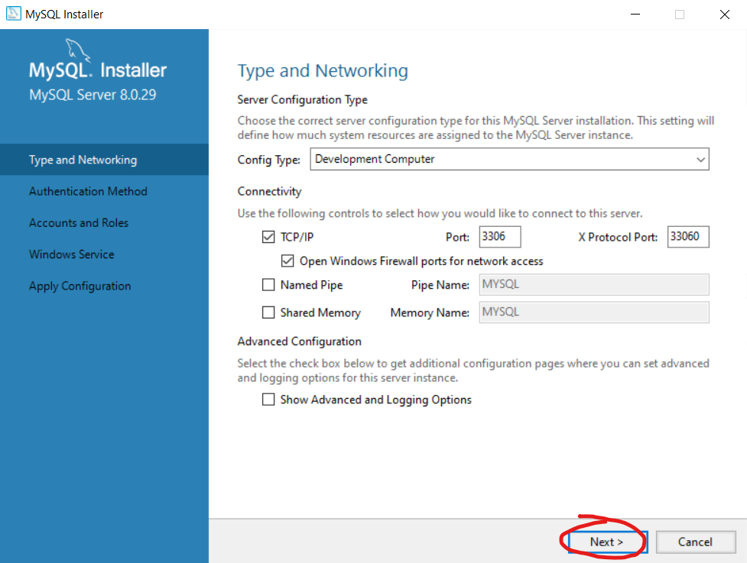

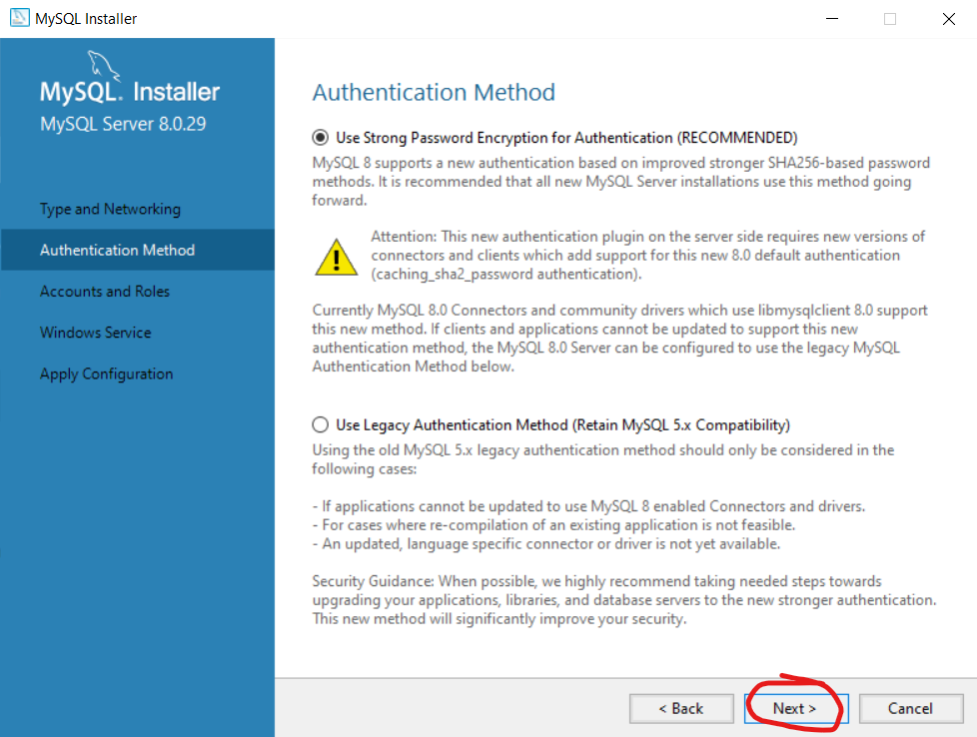

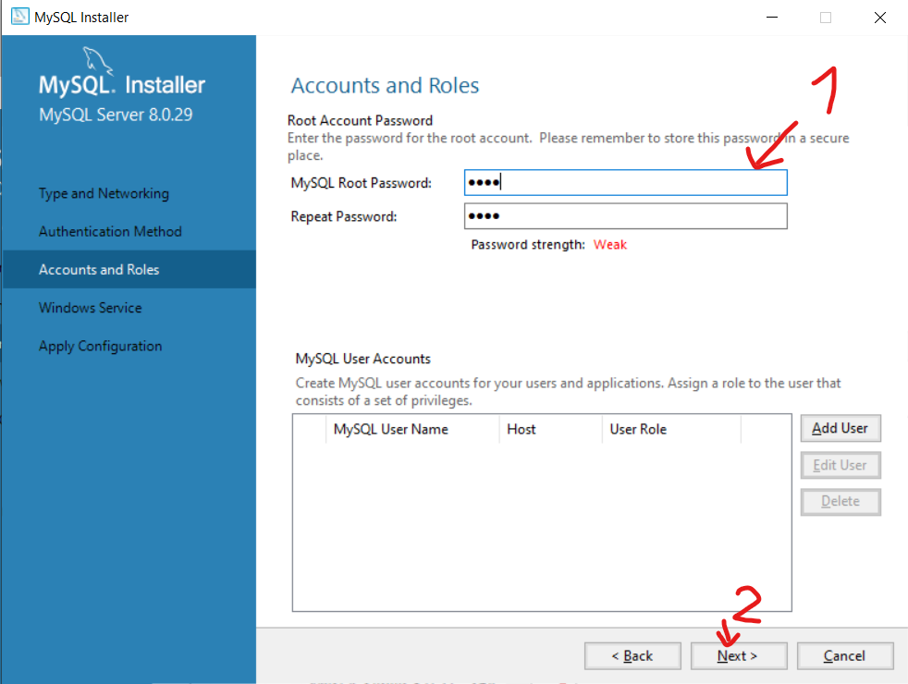

(1)Type in password and REMEMBER it

(2)Next

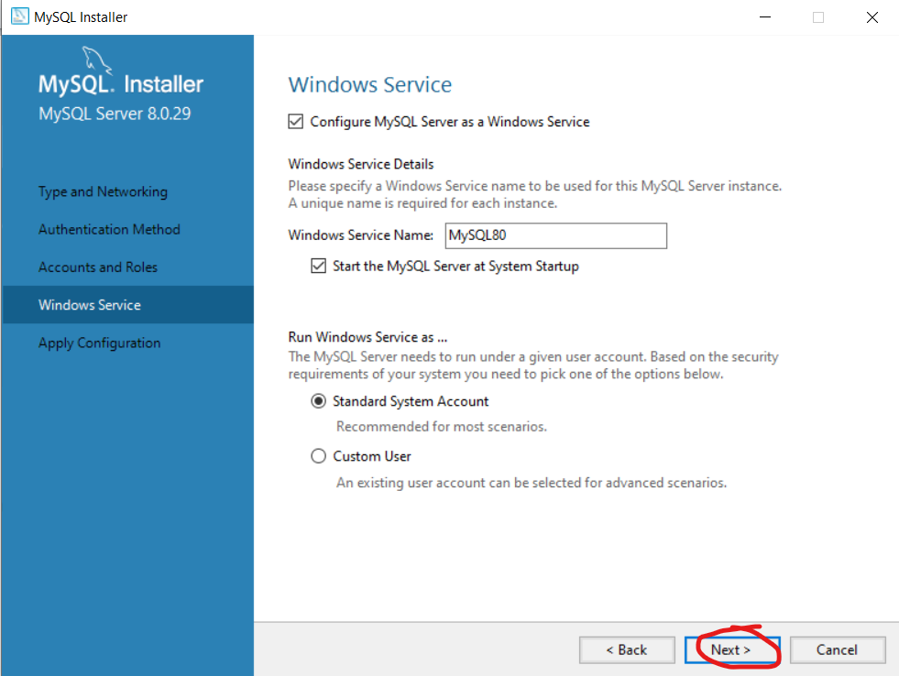

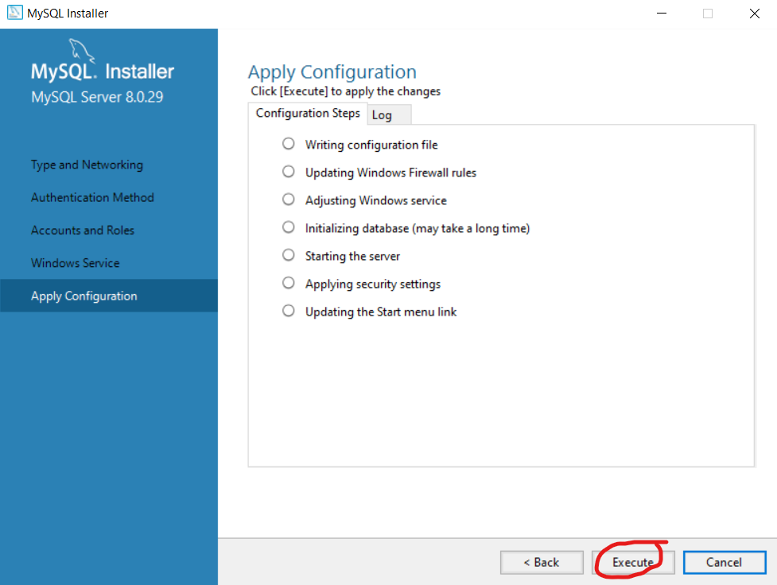

Execute, wait and finish

Successfully created a server

3B/ My SQL workbench is a pretty standard linear installer so just open the installer and install

4/ Open MySQL workbench

Do the following 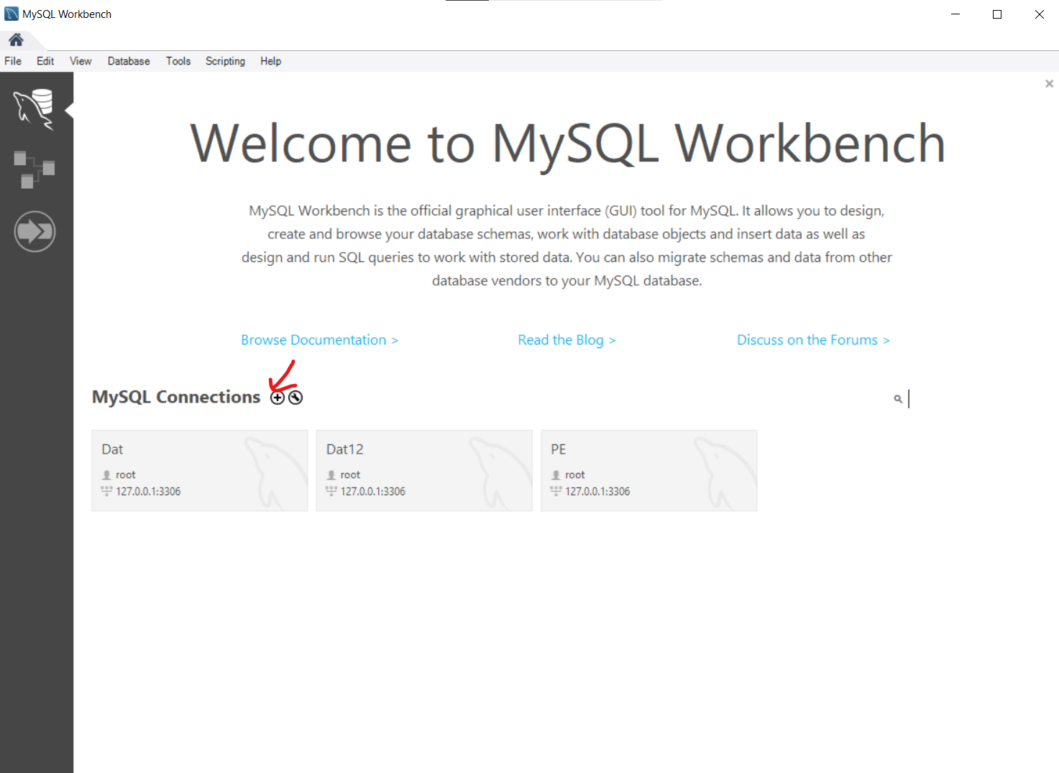

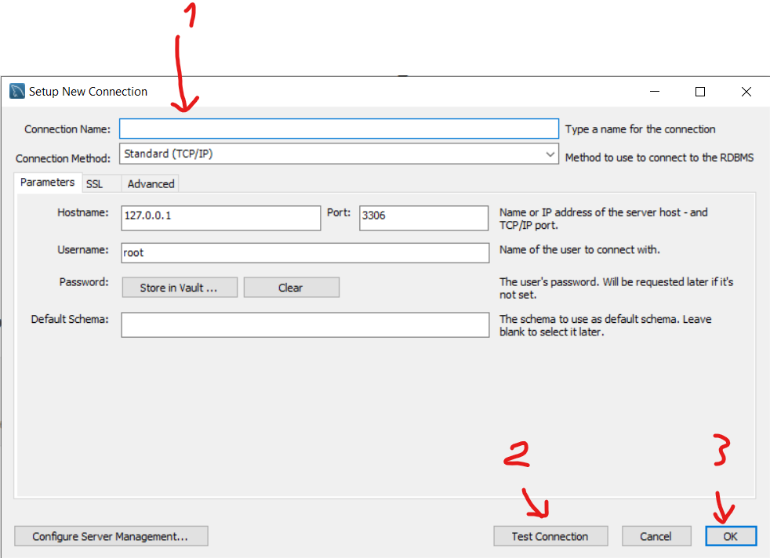

1. Type in the name (whatever don’t care)
2. Test the connection
3. Ok for finish

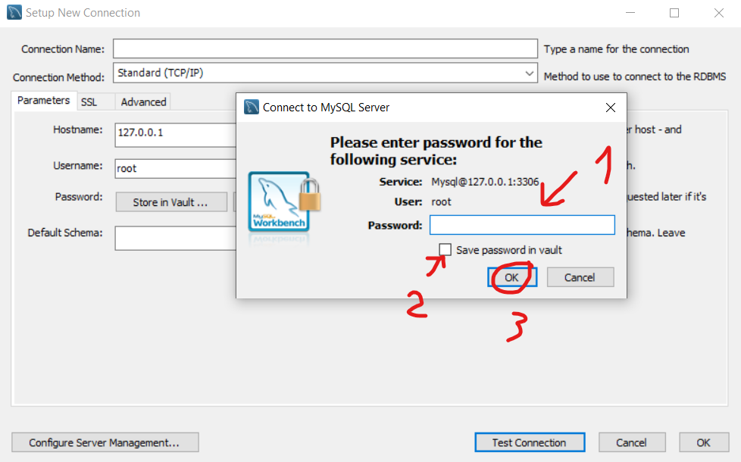

1. Type in THE password
2. Tick if too lazy to remember password
3. Done

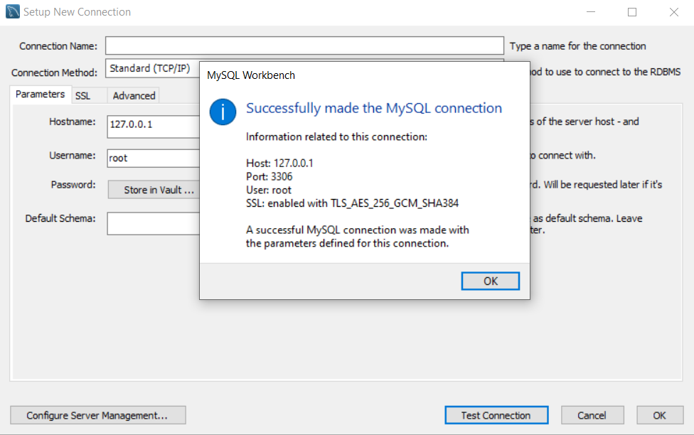

EZ server

**Open the mwb to see the tables and relations, then pass it into local host**

*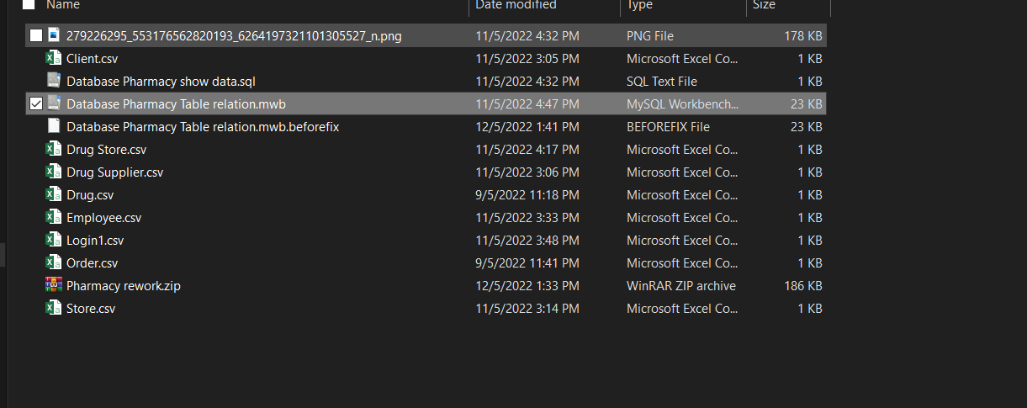Download and extract Pharmacy rework.zip*

*Open Database Pharmacy Table relation.mwb*

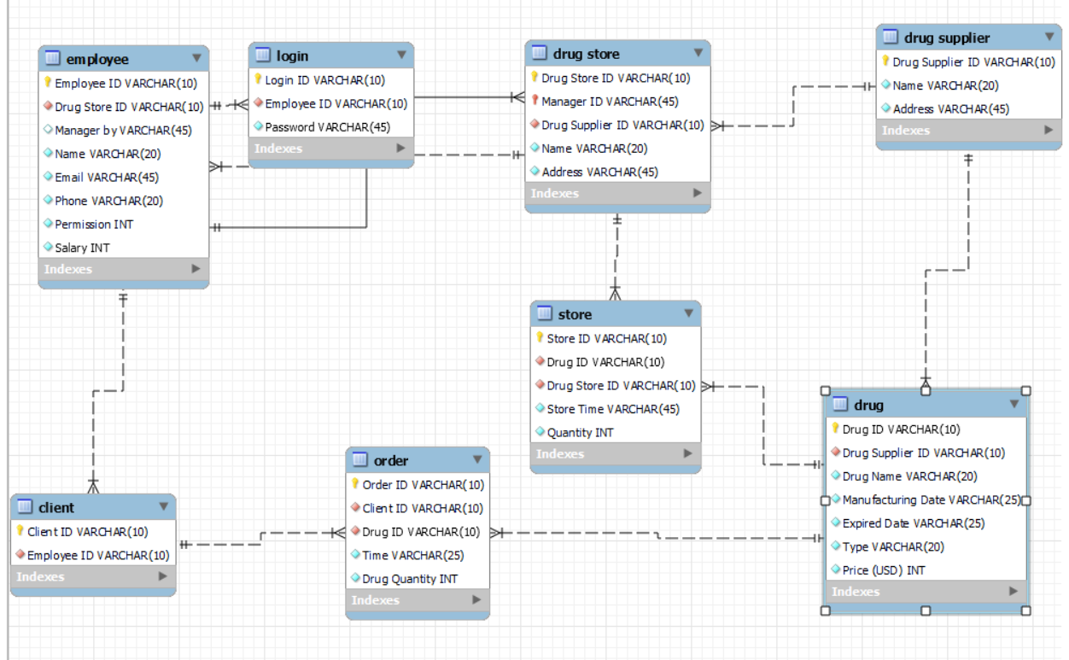

We have 8 tables: employee, login, drug store, drug supplier, client, order, store, drug.

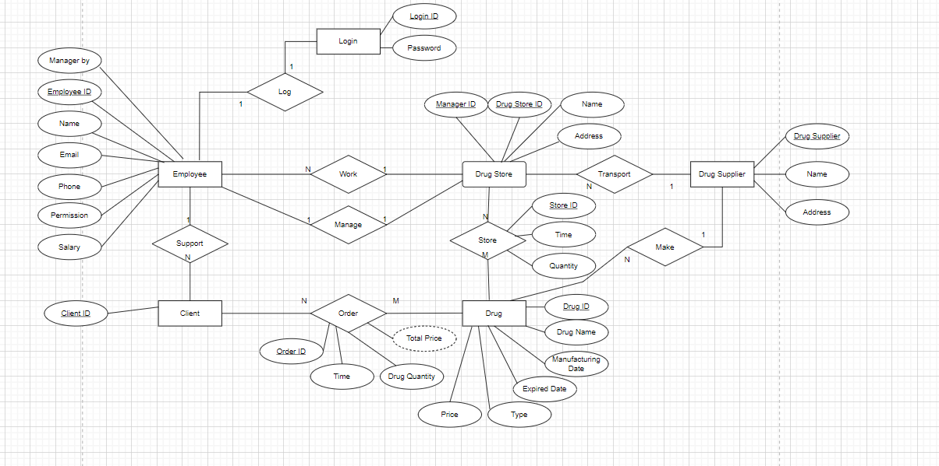*select database/forward engineer, next all until finish and closed*

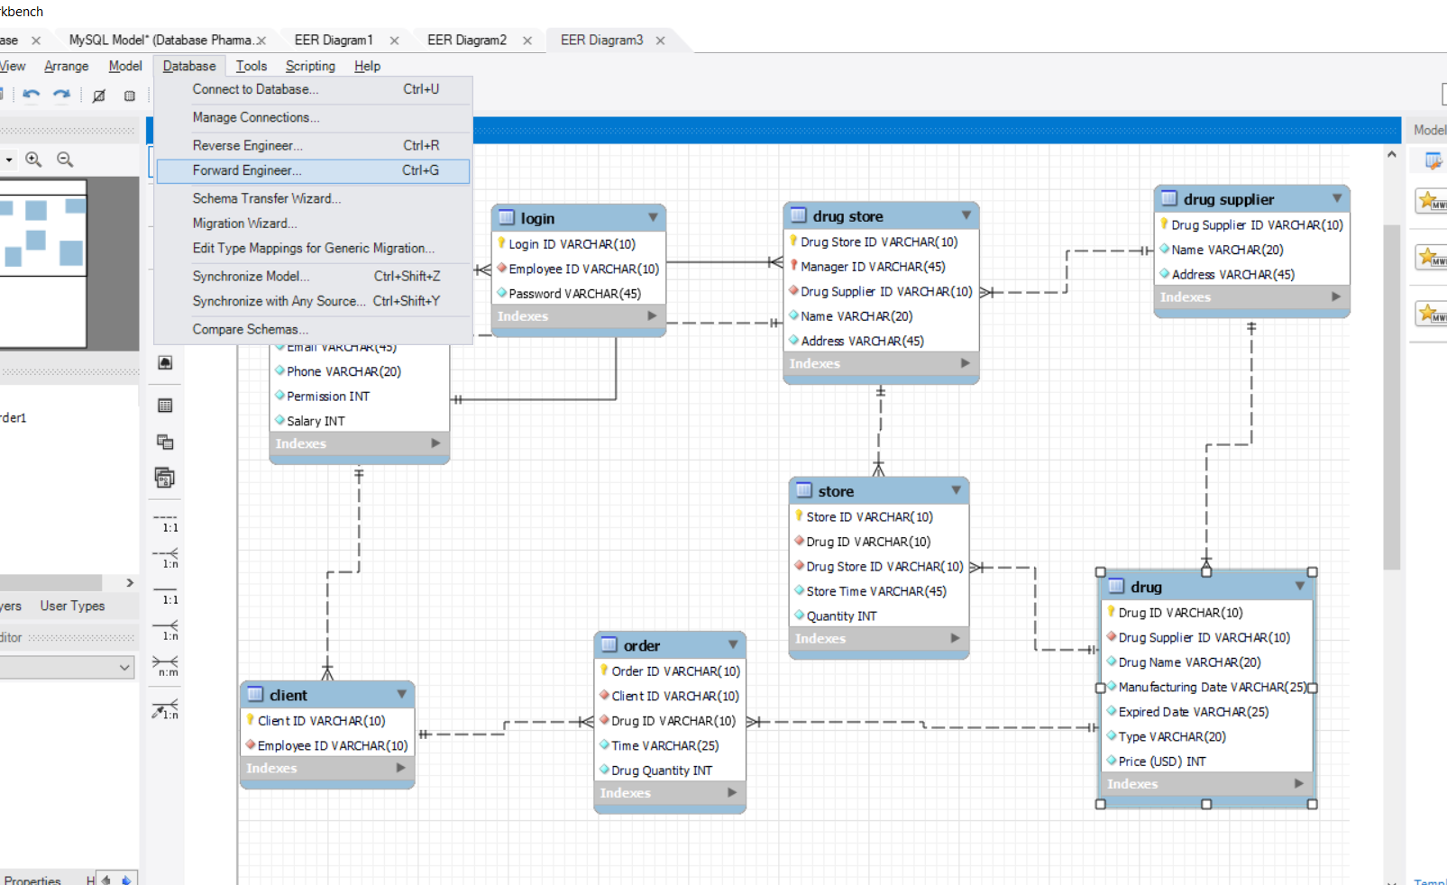

*Press next until finished*

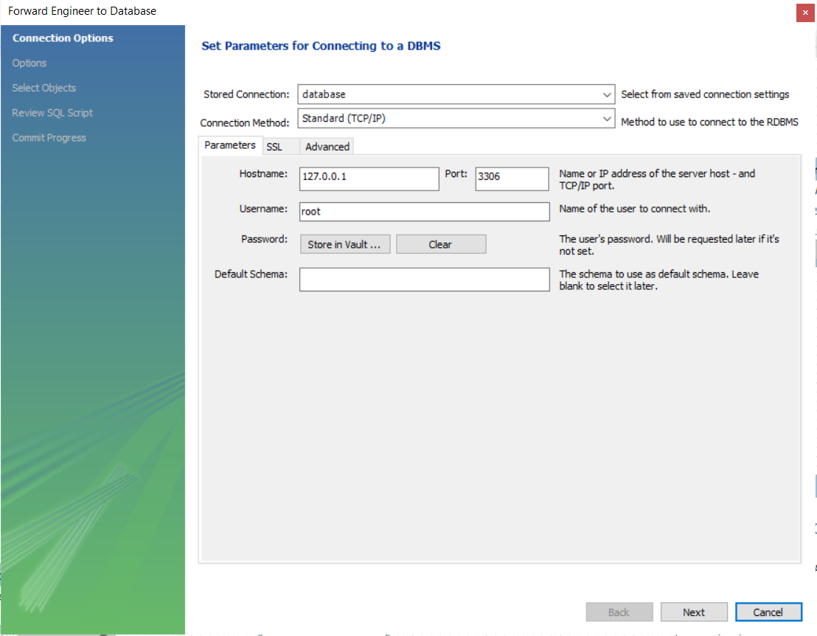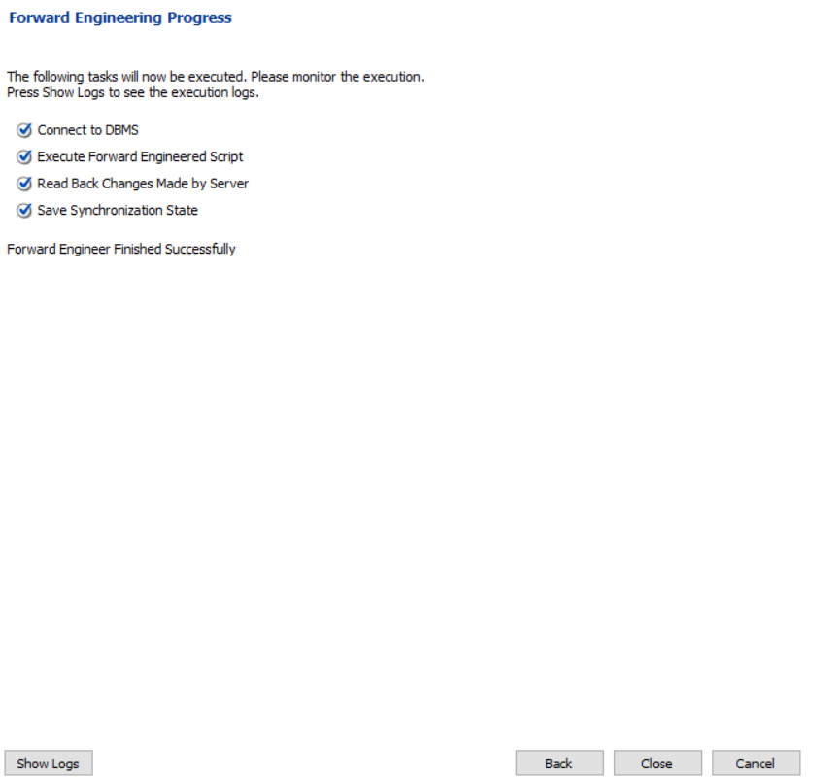

Then closed

*Go to the local host name, if you meet the 1 interface, just click the schemas and it will turn to the second interface,then press the button in the red circle in second interface*

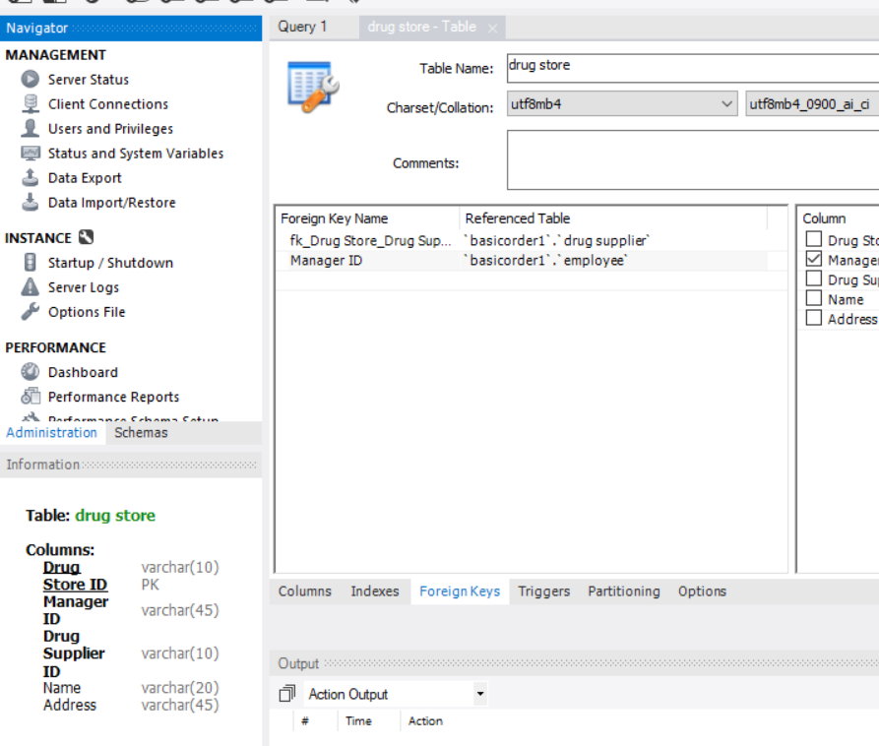*Then the basicorder1 is appear.*

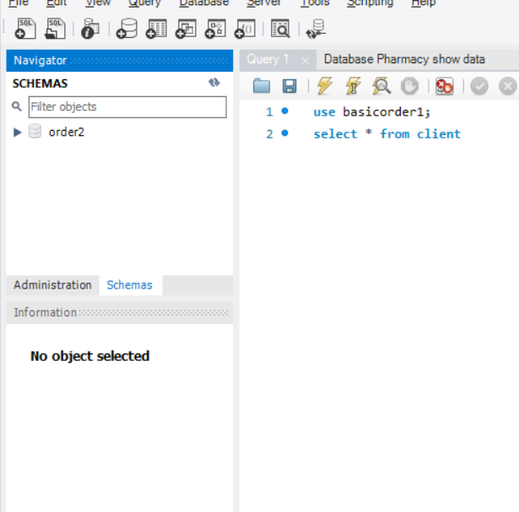

2

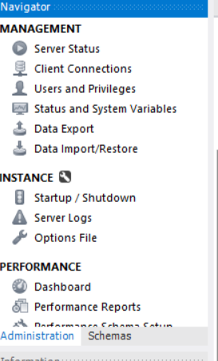

1

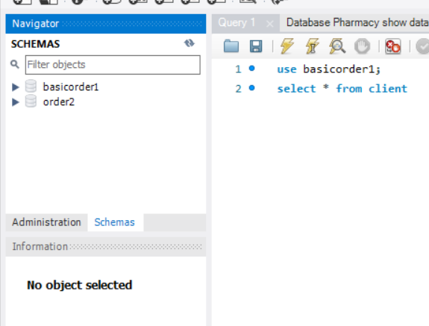

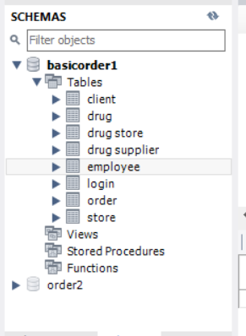

Open the basicorder1 schema, tables

*Right click to drug store table*

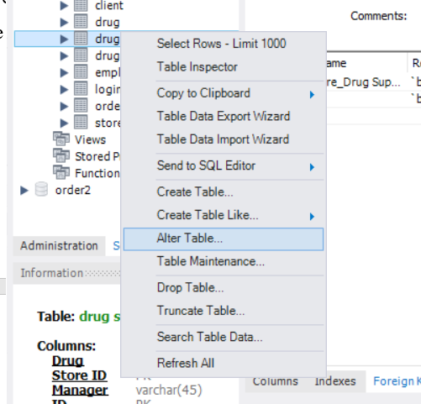

Click Alter Table

Alter the table in drug store Delete the PK and FK of Manager ID

//Explaination: because avoiding the “cannot add a child row in foreign key”

// We will retake it back.

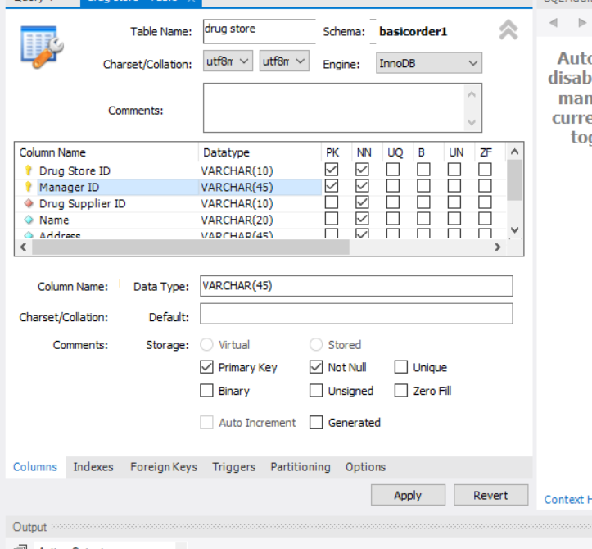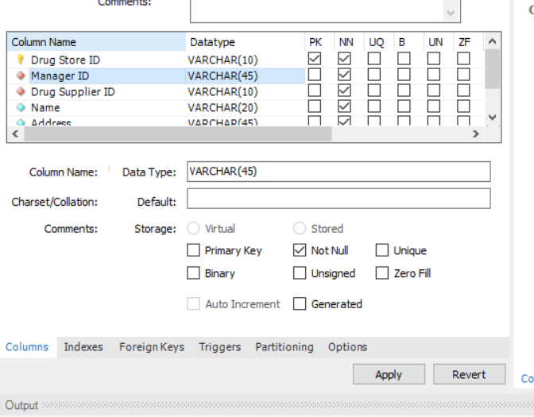

*Select foreign Keys*



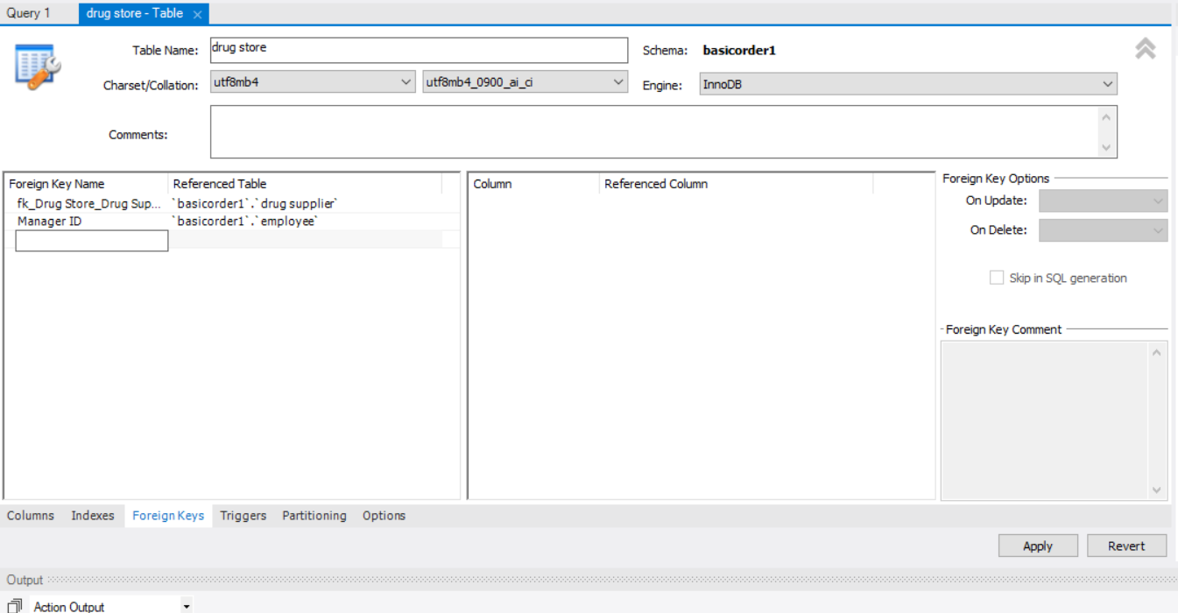

*Delete the Manager ID then apply*

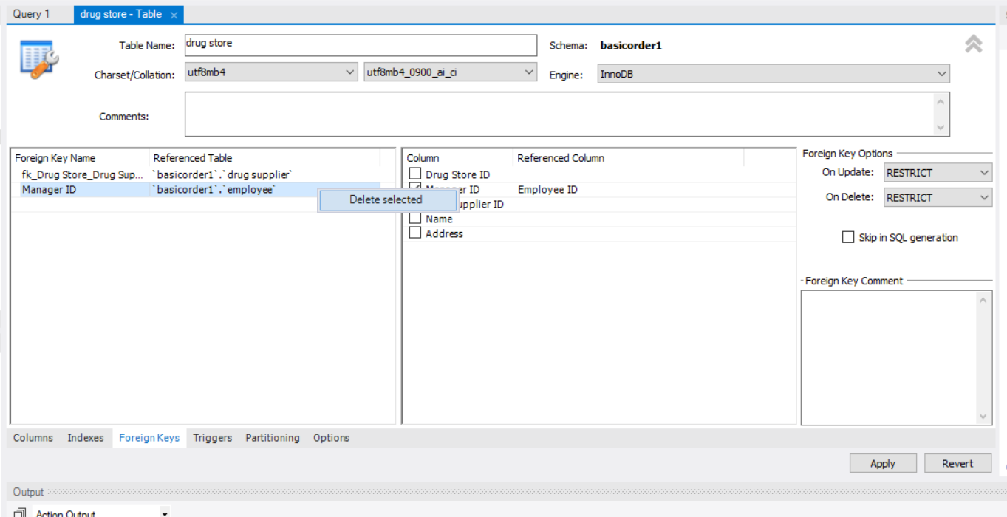

**Import data from csv to the table**

*Basic step to import data from data set in order for the program to work. Keep on repeating the process in the image while following* the Drug Supplier.csv -> drug.csv -> drug store.csv -> store.csv -> employee.csv -> login1.csv -> client.csv -> order.csv // must follow the *“order to avoid ‘cannot add a child row in foreign key’”.*

Click the right click on the table in basic order schema.

Select table data import wizard:

**Drug Supplier**

The csv file in the Pharmacy rework.zip

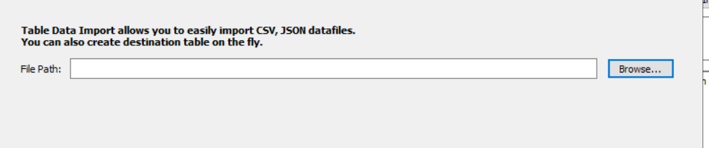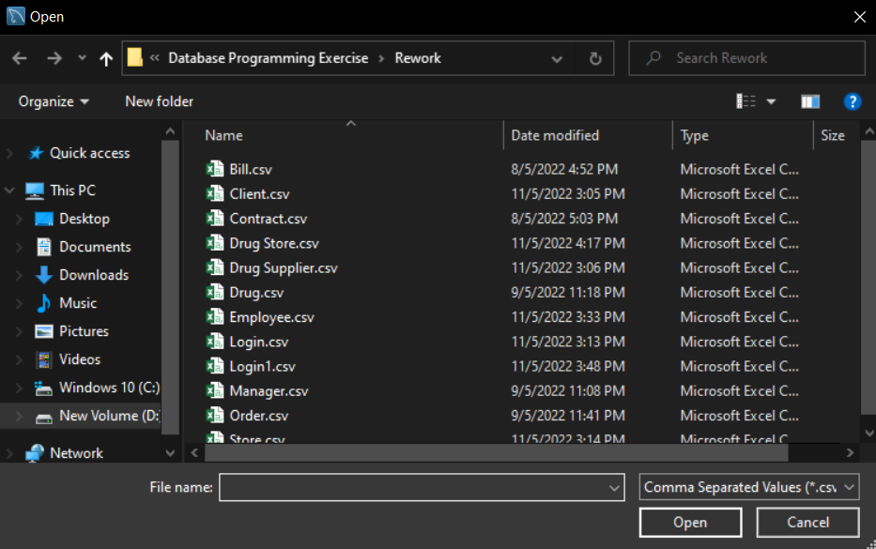

Select the csv corresponding to the table

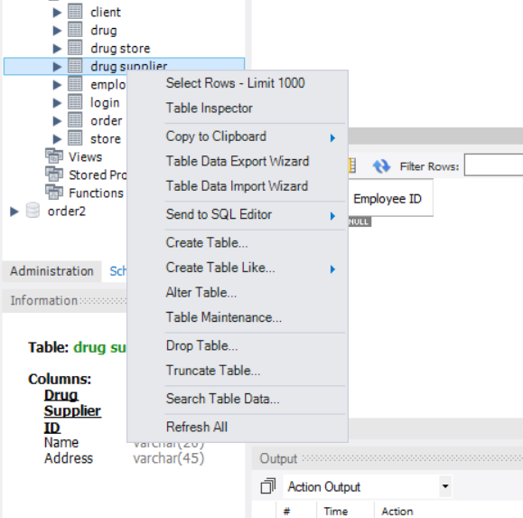

Click next until finish

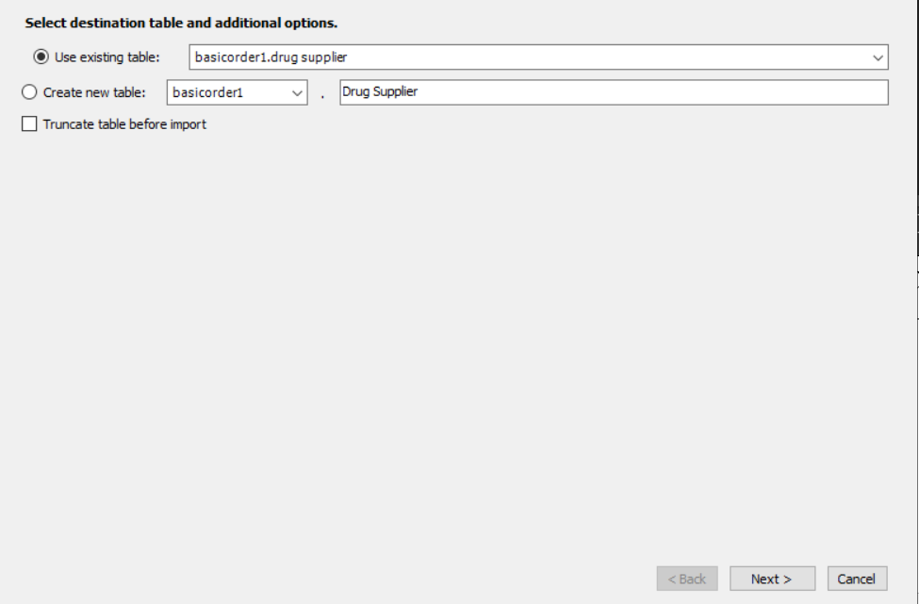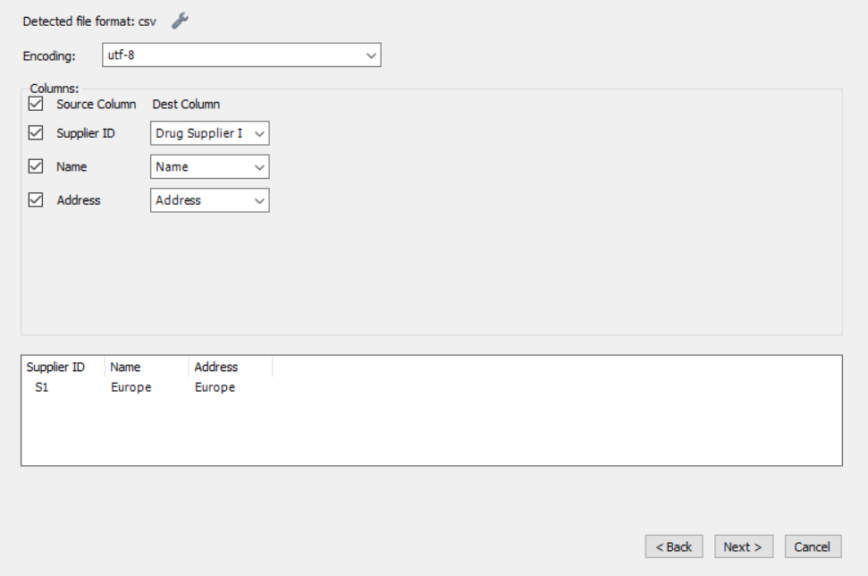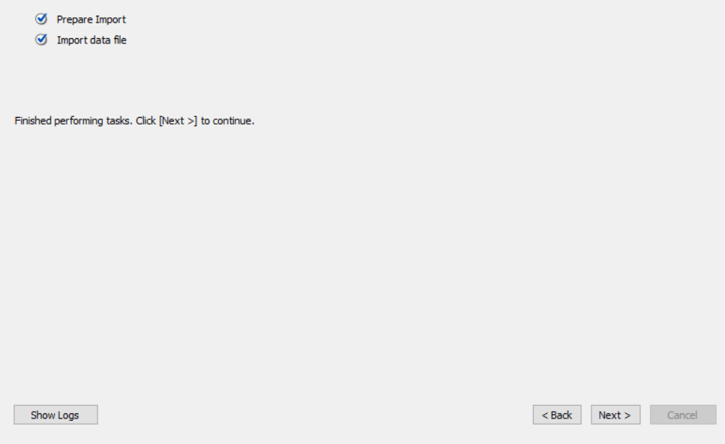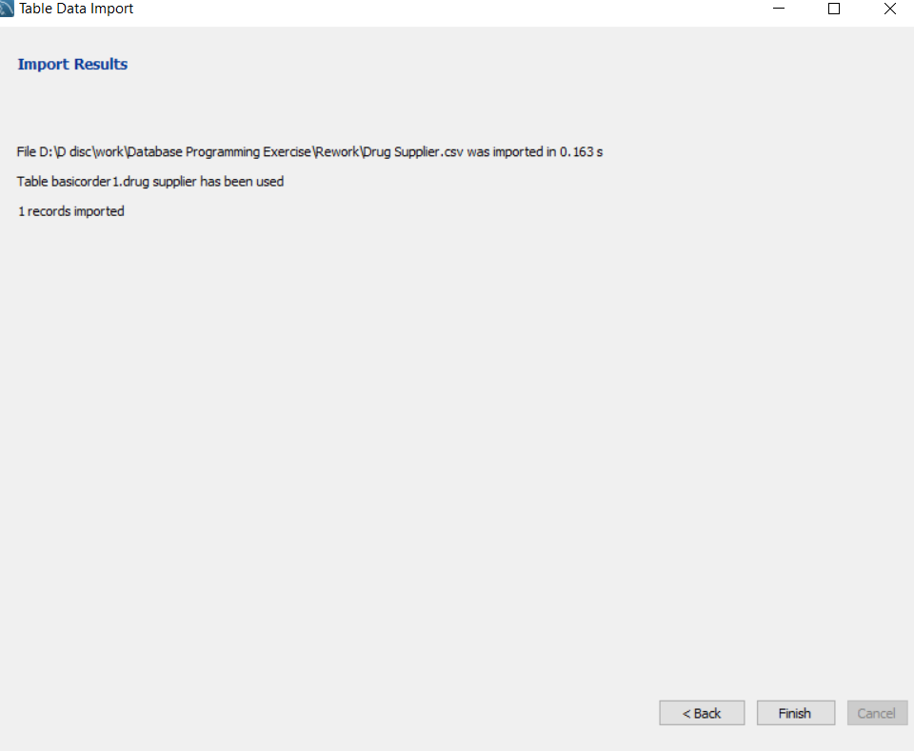

Note that n (n!=0) recoreds means OK

//You just need to import 1 time, else it will show duplicated.

*After adding all* ***the raw data*** *from csv to the basic order*

*Add* ***PK, FK*** *to* ***Manager ID*** *again (because it was deleted in the previous step)*

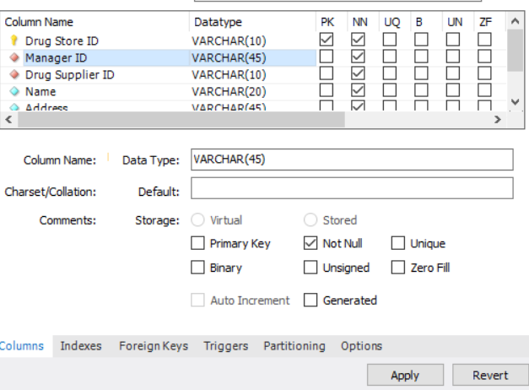

//You just need to import 1 time, else it will show duplicated.

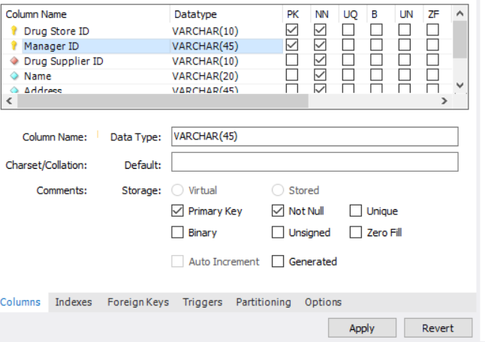

Select foregin key

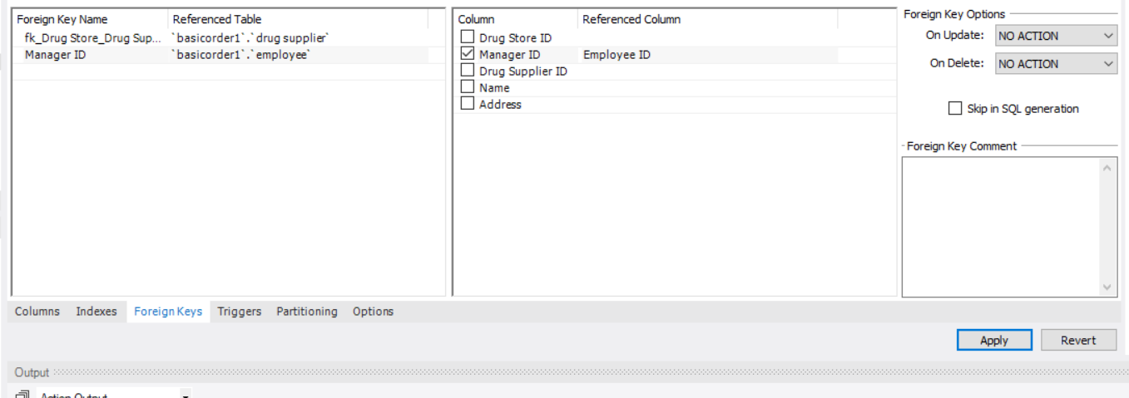

Insert here and type Manager ID reference to employee

Select column Manager ID and reference column Employee ID

Then press apply

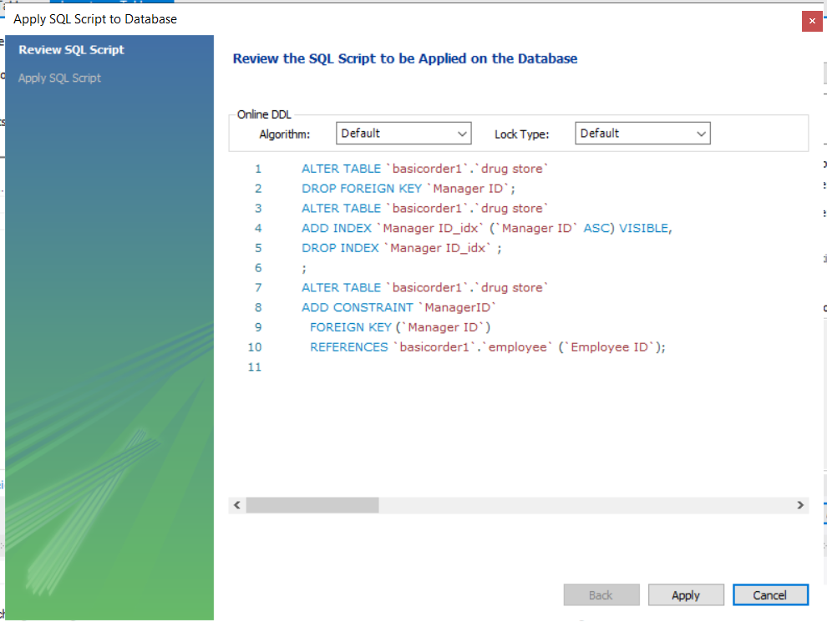

**We finished add data to database from csv**

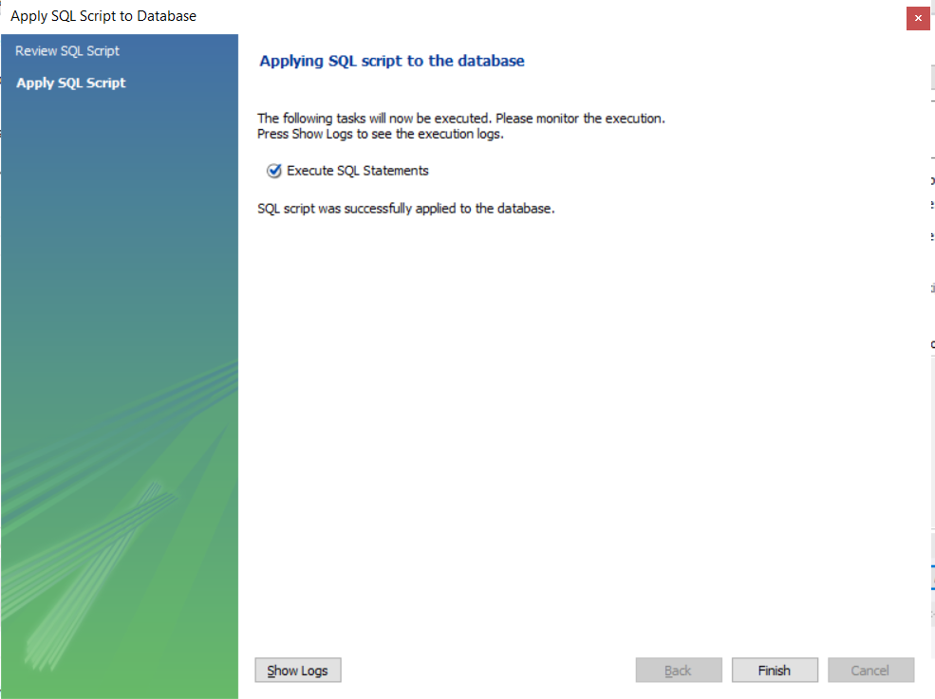

**Presh Finish**

**Show the data**

*Select Pharmacy show data.sql*

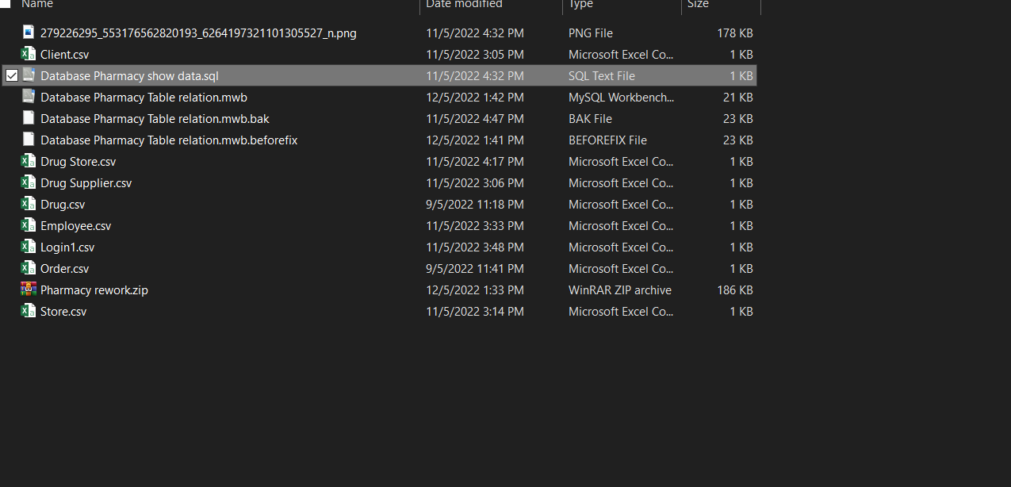

***Copy all this text***

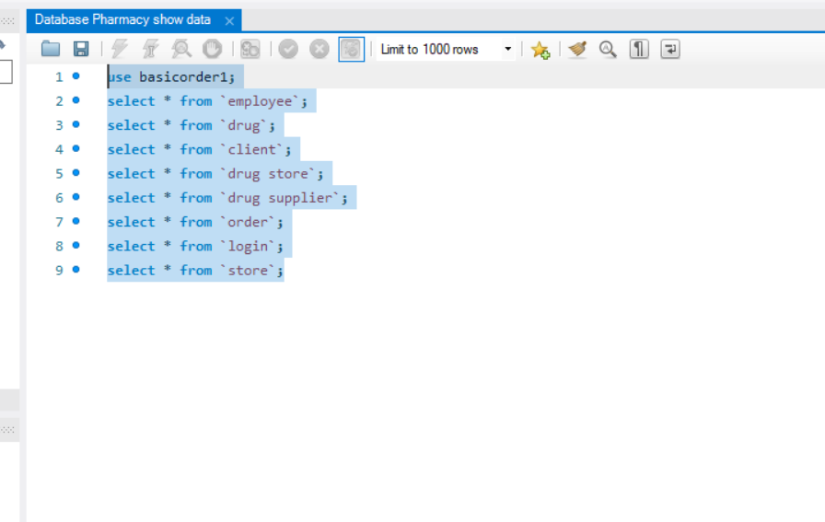

***Pass to query 1 and press the lightning button***

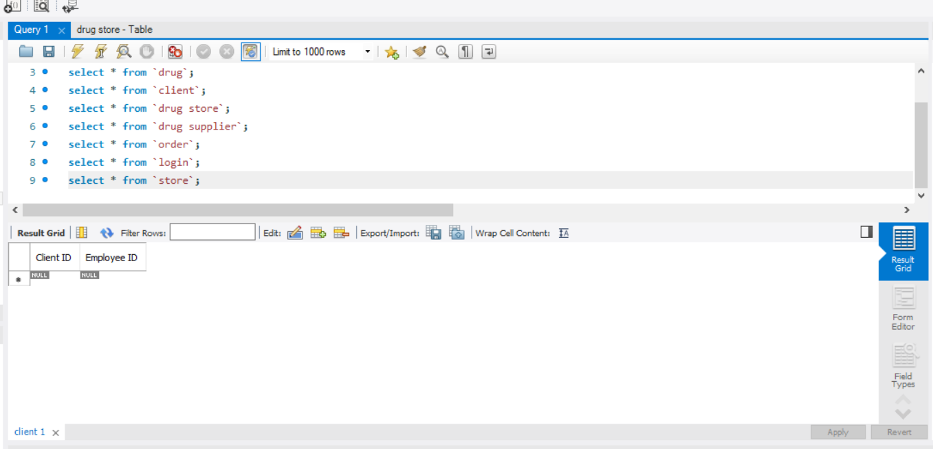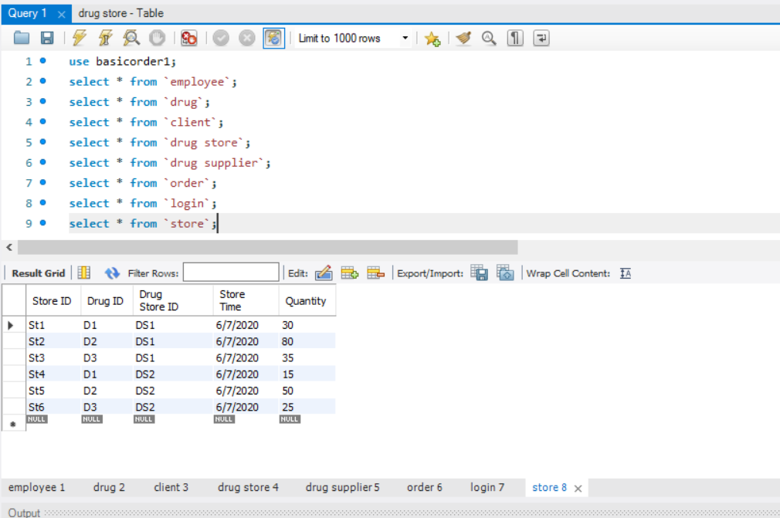

***Result***

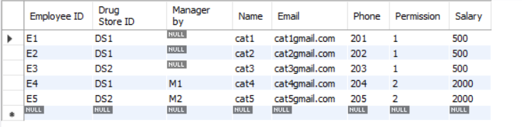

Employee table

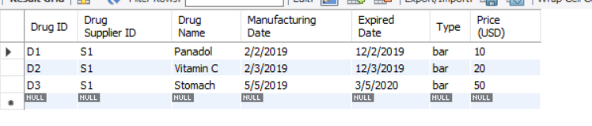

Drug table

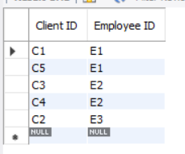

Client table

Drug Store table

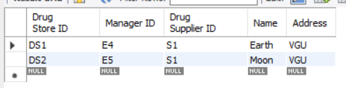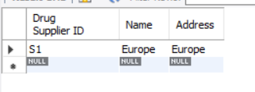

Drug Supplier table

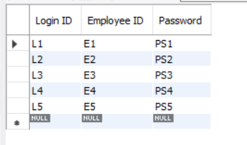

Login table

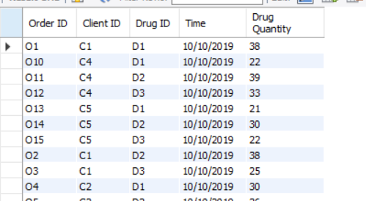

Order table

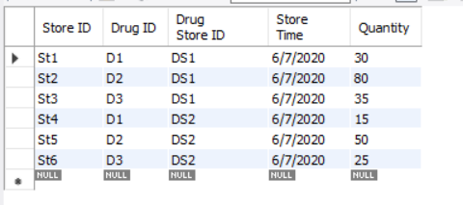

Store table